Faculty of Science and Technology

Semester 1

(Assignment)

Unit Name: Biochemistry
Unit Number: 6530
Marks on this assignment: 45
Marks for assessment: 35%
Examiner’s Name: Dr Regan Ashby

Instructions for Students (PLEASE READ CAREFULLY):
- Answer all questions. ONLY answer questions in the space provided. If you require more space, please use the last page of the assignment but clearly indicate which question you are answering. The last page is intentionally blank.
- Type all answers, please DO NOT hand-write your answers.
- If you wish to draw a picture, please insert the picture as an image within the question you are answering or use the drawing function in Word or Adobe Acrobat. You may insert drawn diagrams created by you; you cannot insert published images/pictures or images/pictures generated by others.
- You will only be able to upload a single document, that of your assignment, no other documents can be uploaded.
- Please save your assignment as a Word document or pdf file, please DO NOT save your document in any other format.
- The second last page of the assignment contains the Standard Genetic Code.

SIGNAL TRANSDUCTION

- Describe how the enzyme adenylyl cyclase is activated by the binding of epinephrine to its receptor.

(4 marks)

- Define the structure and function of a voltage-gated ion channel.

(3 marks)
ENZYMES

- What is meant by the term activation energy when referring to a chemical reaction? How do enzymes alter the activation energy of a reaction and what effect do enzymes have on the equilibrium of the reaction (give specific details)?

(4 marks)

- From the Lineweaver-Burk plot below, determine ½V_{max} (show your calculations).

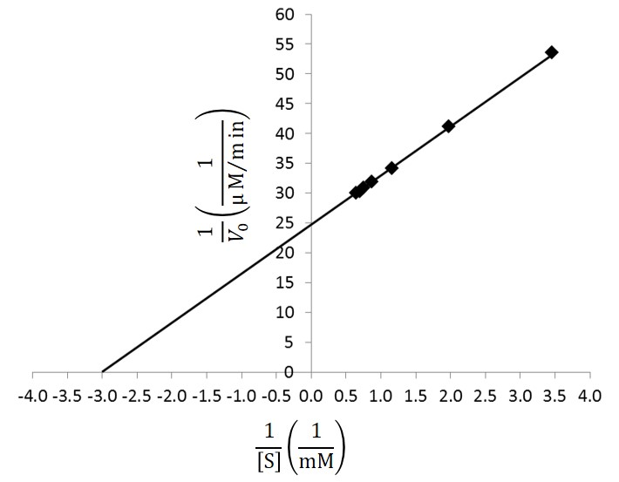

(2 marks)

- Part A: Based on the Lineweaver-Burk plot below, what type of reversible enzyme inhibitor is present?
Part B: What effect does this inhibitor have on the V_{max} and K_{m} values of an enzyme (give reasons)?

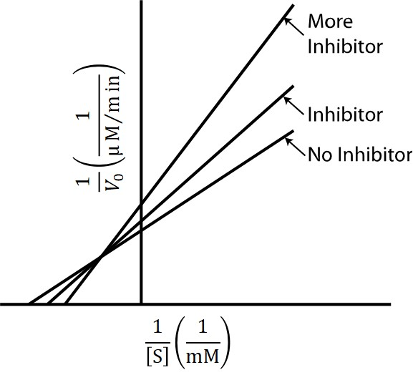

(3 marks)
NUCLEOTIDES AND NUCLEIC ACIDS
- Describe the chemical structure of a nucleotide. How do the nucleotides that form DNA and RNA differ?

(3 marks)

- Part A: You are investigating the properties of two genomes, one which is composed of 22% cytosine (C) residues and the other which is composed of 30% cytosine (C) residues. From this information, what percentage of A, T and G residues would you expect to find in both genomes?
Part B: Which of the two genomes above would have a higher melting temperature (explain your reasoning)?

(4 marks)
- Describe the secondary structure of DNA. How is this structure held together?

(4 marks)
DNA REPLICATION

- What is the role of primase during DNA replication? Is primase also needed during the process of transcription (explain your reasoning)?

(3 marks)

- How is DNA replication a semi-conservative process? How does a semi-conservative process differ from a conservative process?

(3 marks)
TRANSCRIPTION

- What is meant by the terms ‘template’ and ‘non-template’ strand? What is the role of the template and non-template strand in transcription?

(2 marks)

- What is the role of the 5' cap that is produced during transcription? Explain how the cap is formed.

(3 marks)
TRANSLATION

- Describe the process of ‘amino acid activation’ during translation.

(3 marks)

- Using the non-template DNA strand given below, write down the following sequences:
  - The DNA template strand sequence;
  - The mature mRNA sequence;
  - The protein sequence (the standard genetic code is given on the following page).
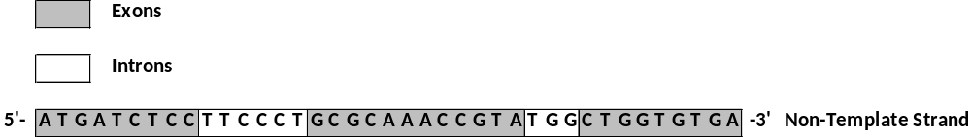

(4 marks)
PLEASE TURN OVER THE PAGE FOR THE GENETIC CODE
Standard Genetic Code
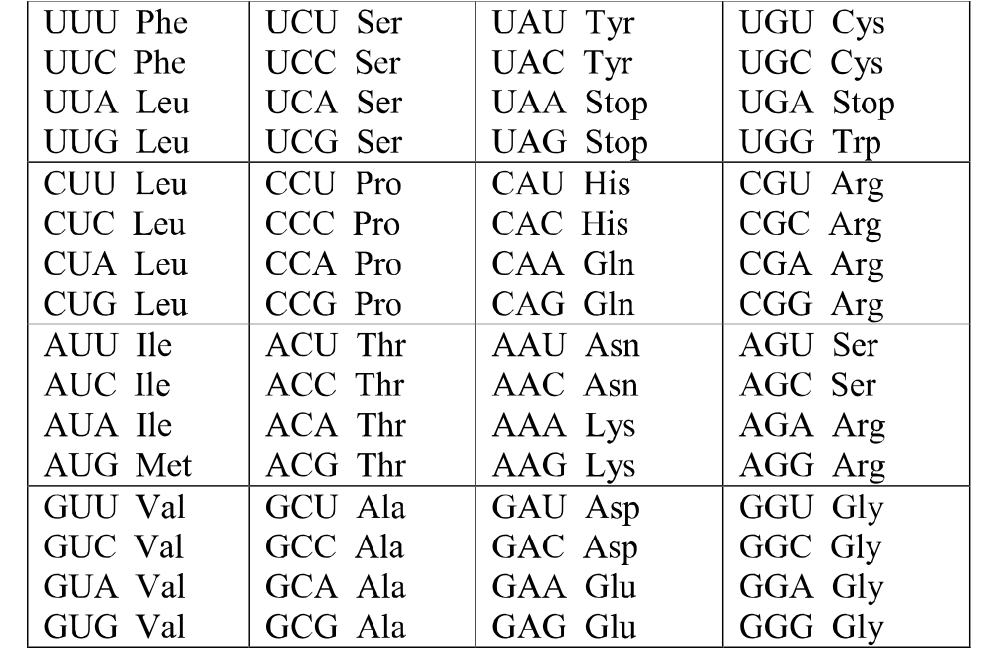

SPARE PAGE IF REQUIRED – Please clearly identify which question you are answering

END OF ASSESSMENT ITEM

